Game task Clothes Shop (Team LSW)

The game lets the user play as a fictional character that have arrived to this world, a strange shop owner greets and gives him a helmet, a ninja costume and a haircut style, now the player can wander around the small city where he can interact with an object or choose to enter the shop and meet the strange shop owner, then the player can customize his character between different costumes, hats and hairstyles.

**Player**

The player can move in 8 directions, each one with different animation, this animation is completely dynamic to the selected costume, this means it only exist one shared animation for all costumes (this will be explained in **clothes customize** section), the player also can interact with the world around him and start short conversations around it.

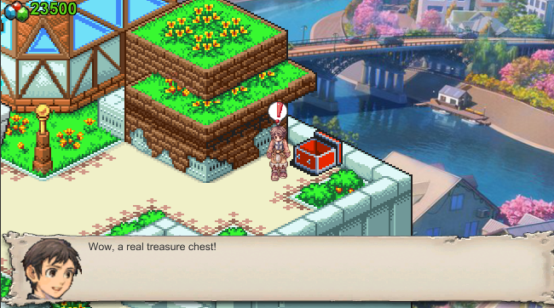

**Chat System**

The user can interact with the shop owner, the border of the map, swords inside the shop and an empty chest found in the town, each of these interactions had their own conversation. This system uses scriptables to make the flow easier for a non-programmer, as the person only needs to customize the scriptable via unity editor (not extra coding needed).

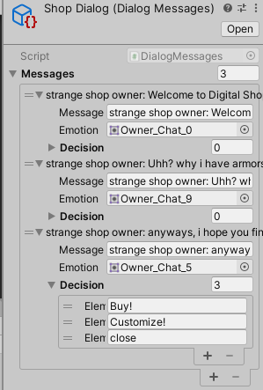

The user has to press the spacebar when an icon appears above the user, this will show the chat UI, to advance in the conversation a spacebar needs to be pressed again, the conversation can offer the user option to choose from and depending of the choice an event triggers.

**Clothes customize**

This one was challenging, this system lets the user choose from the owned costumes, and depending of the choice the system draws and overwrites a sprite sheet where all the sprites of the animations are.

The system takes the head sprite, the hat sprite and the body sprite sheet and draws pixel by pixel a new sprite sheet with the merged sprites of head, hat and body.

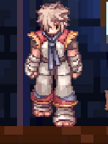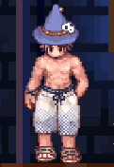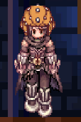

This system has his own UI designed to make things easier.

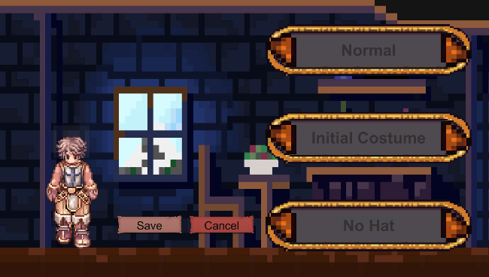

**Shop System.**

The player doesn’t have all the costumes, to get more of them the shop is implemented, the UI is composed of the main panel with the list of available items, below of it is displayed the description, at the right side is the icon of the item selected at the moment and at the left side is the close button.

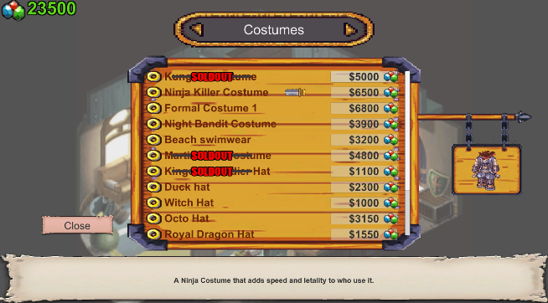

If an item is already bought it will be displayed as “SOLDOUT”.

**The process**

During these days I’ve been working to complete the tasks of the interview and to achieve amazing results, it was challenging and interesting, I enjoyed working on these tasks, I learned multiple things and got better on another ones.  
  
I’m more than satisfied with the achieved result, I always enjoy programming an go beyond the main ideas I have at the beginning.